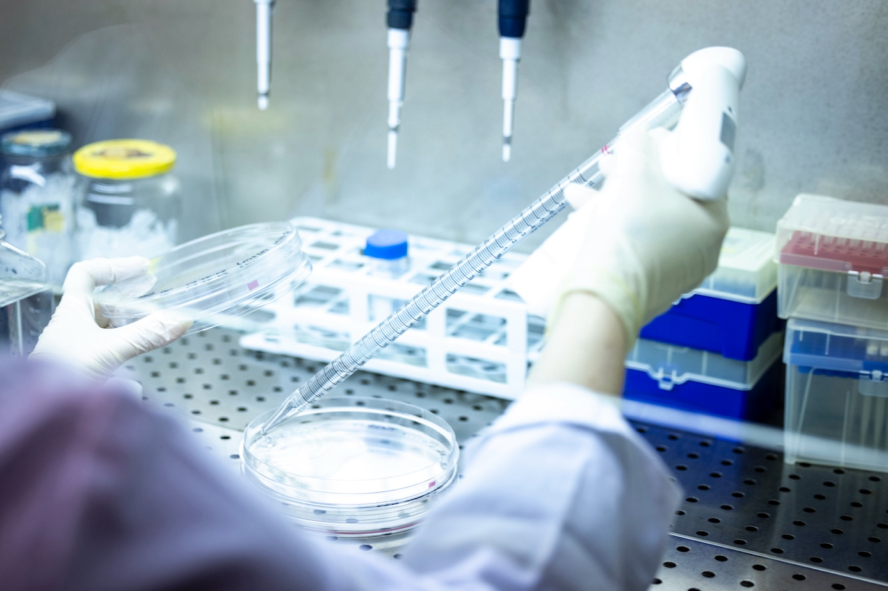 Photo @HD/Reporters

Brussels, 7 December 2023

Cancer : towards a new treatment for leukaemia
Recherche

Researchers led by François Fuks – Laboratory of Cancer Epigenetics, ULB Faculty of Medicine, ULB Cancer Research Center and Jules Bordet Institute, H.U.B. – have made a major breakthrough in the understanding and treatment of leukaemia. Published in the prestigious journal Molecular Cell, their discovery paves the way for new methods of detecting and treating cancer. This discovery is based on the previously unsuspected role of a key gene that has mutated in more than 50% of leukaemia patients.

Around 320,000 new cases of leukaemia, a type of blood cancer that can affect all population groups, are diagnosed every year in Europe. In children, cases of leukaemia make up a third of diagnosed cancers. Chemotherapy is the main treatment for leukaemia. Often, the exact cause cannot be identified and the molecular and cellular mechanisms responsible for leukaemia remain shrouded in mystery. Discovering new detection methods and new treatments to eradicate leukaemia is therefore a major challenge in oncology.

Messenger RNA has been in the news in recent months, in connection with COVID-19 vaccinations. In an article published in Molecular Cell, researchers from the Université libre de Bruxelles (ULB) and the Bordet Institute, Brussels University Hospital (Hôpital universitaire de Bruxelles – H.U.B.) are opening another equally innovative avenue of research: novel anti-cancer therapies using the complex alphabet of messenger RNA (or RNA epigenetics).

As with DNA, along with its 4 well-known letters (A, U, G, C), RNA's chemical make-up also includes additional letters. This is the case for the letter m5C, or methylation of messenger RNA, which plays an essential role in gene regulation through the reading of m5C by proteins that bind to it, called “readers”. These m5C readers have still not been described in detail and their role in cancer is unknown.

The recent work of the team led by Prof. François Fuks – Director of the Laboratory of Cancer Epigenetics, ULB Faculty of Medicine and Bordet Institute H.U.B. and Director of the ULB Cancer Research Center (U-CRC), Université libre de Bruxelles – has identified a new RNA reader, SRSF2. For the first time, it is shedding light on the SRSF2 protein’s key role in the development of leukaemia.

The SRSF2 gene is one of the most frequently mutated genes in leukaemia cases: up to 50% in certain types of leukaemia. The researchers demonstrated that the SRSF2 protein reads the m5C modification in RNA; they also highlighted a previously unsuspected molecular mechanism that can lead to leukaemia: the mutation of SRSF2 alters its ability to read m5C in RNA, which inhibits its function of regulating messenger RNA. Furthermore, by analysing nearly 700 samples taken from leukaemia patients, Prof. François Fuks and his colleagues were able to identify a new group of patients whose chances of survival are particularly low due to the reduced ability of SRSF2 to read m5C.

This research, which is part of a boom in discoveries in the field of the RNA alphabet, was published on 7 December 2023 in the journal Molecular Cell.

These discoveries should not only begin a new chapter of knowledge in our understanding of why leukaemia appears, but should also lead us to a new paradigm in the diagnosis and treatment of leukaemia, based on the epigenetics of RNA. In concrete terms, the discoveries could lead to specific diagnoses of patients with a poor vital prognosis, in whom the “m5C reader” function of SRSF2 is affected. Moreover, a new therapeutic approach to leukaemia could be envisaged by developing an inhibitor that could help SRSF2 to read m5C correctly again, as this reading ability is reduced in patients with the SRSF2 mutation.

The work is supported by the F.N.R.S, Télévie, Welbio, the Fondation contre le Cancer, an ARC, the Fondation ULB and Wallonia

Scientific contact :
François Fuks
Laboratory of Cancer Epigenetics, Faculty de Medicine ULB and Bordet Institute H.U.B.
Mail : mailto:francois.fuks@ulb.be

